*Standardized Testing and its Impact in Academic Success*

*Part I: SAT Average / Completion Rate*

Based on simple linear regressions done on 10 datasets containing universities’ average SAT scores for admitted students and their graduation to admission ratio, there is a significant, positive correlation between SAT score averages and graduation rates (Figure 1). Figure 2 shows that this relationship has not changed over the 10-year period from 2008 to 2018.

*Figure 1. Scatter plot and best-fitting line for universities’ average SAT scores vs Completion Rate for 2018-2019 school year. The R2 shows that this is an acceptable linear model describing this correlation*

*Figure 2. The slope of each of the linear model was plotted to assess whether there are changes in this relationship over time*



A multivariate regression was performed on all the school years to determine whether a specific category of the SAT (i.e. critical reading and math) has a greater impact in the completion rate. Table 1 shows that there is not a significant difference between the coefficients preceding the variables representing the critical reading and math categories. Table 2 shows the coefficients, standard errors, and p-values for the predictors of the dependent variable. The p-values are < 0.05 suggesting significant contributions for all variables used in the model.

*Table 1. This table summarizes the coefficients obtained from the multiple linear regression over the span of 10 years.*

|  |  |  |  |
| --- | --- | --- | --- |
| **Variable Coefficients** | | | |
| **YEAR** | **b** | **x_eng** | **x_math** |
| 2008 - 2009 | -0.4631 | 0.0009 | 0.0010 |
| 2009 - 2010 | -0.4627 | 0.0009 | 0.0010 |
| 2010 - 2011 | -0.5081 | 0.0009 | 0.0012 |
| 2011 - 2012 | -0.5071 | 0.0011 | 0.0010 |
| 2012 - 2013 | -0.5056 | 0.0008 | 0.0012 |
| 2013 - 2014 | -0.4976 | 0.0008 | 0.0012 |
| 2014 - 2015 | -0.4873 | 0.0011 | 0.0009 |
| 2015 - 2016 | -0.451 | 0.0010 | 0.0010 |
| 2016 - 2017 | -0.4505 | 0.0011 | 0.0009 |
| 2017 - 2018 | -0.5944 | 0.0009 | 0.0012 |

*Table 2. Important statistics describing the multiple linear regression for 2018-2019.*

|  |  |  |  |  |
| --- | --- | --- | --- | --- |
| **2008 - 2009 multivar reg** | | | | |
| **Variables** | **coef** | **std error** | **t** | **p** |
| const | -0.4631 | 0.028 | -16.34 | 2.00E-80 |
| x_reading | 0.0009 | 1.46E-04 | 5.35 | 3.50E-09 |
| x_math | 0.0010 | 1.35E-03 | 6.18 | 2.70E-19 |

*Part II: Minority Study—SAT Averages and Default Rates*

A linear regression was performed on data from United States Minority-Serving Institutions containing SAT averages and 3-year loan default rates per school. Per *Figure 1*, there is a meaningful correlation between SAT average and 3-year loan default rates for these institutions. The low *f-value* denotes a significant difference between groups.

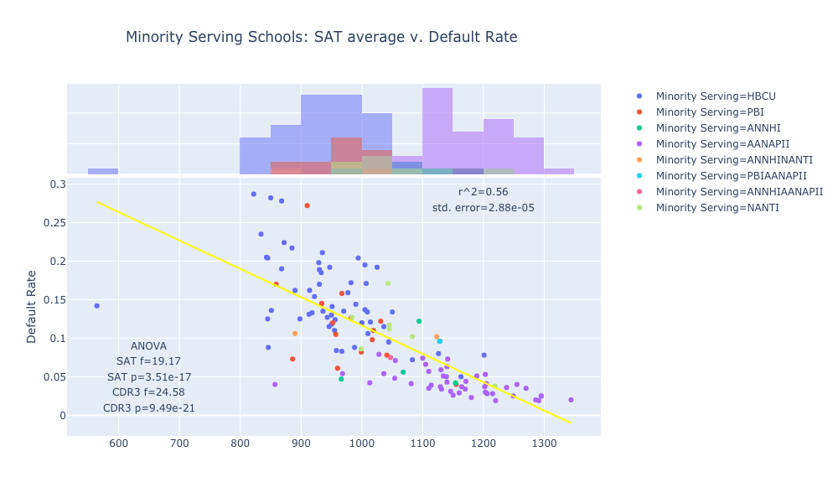

Figure 1: R² of 0.56 denotes a meaningful correlation for the regression. Low P-values similarly denote a meaningful difference in groups.

Using the same data, but limiting to 2 groups, performed another linear regression. Per *Figure 2*, there is not a meaningful correlation between SAT average scores and default rates for these 2 groups, with a low *R²-value* and higher than acceptable *p-value*.

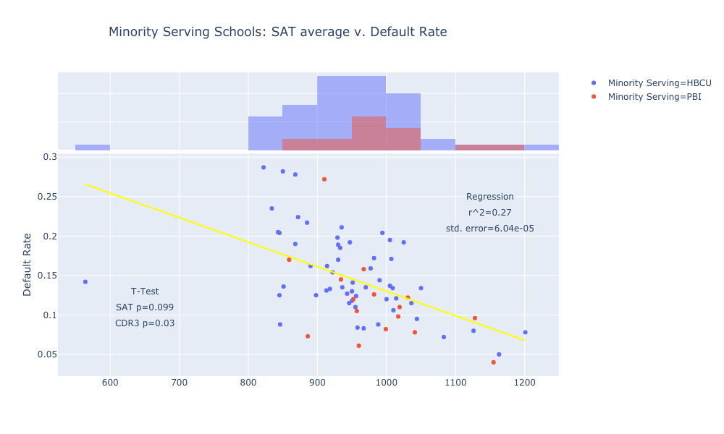

Figure 2

Following the regressions for Minority-Serving Institutions, a scatter map was generated to visualize default rates and associated black student proportions (see *Figure 3*).

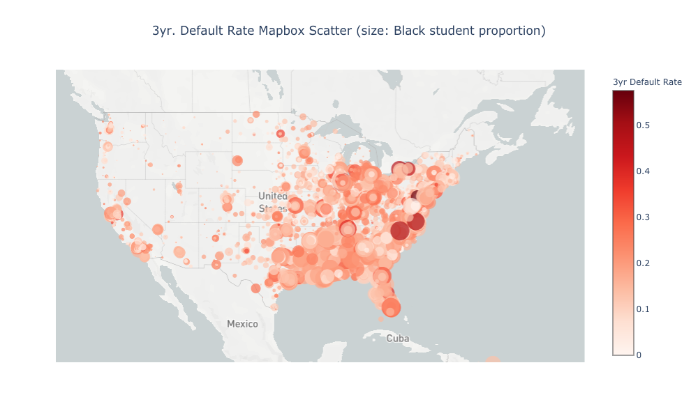

Figure 3

More linear regressions were performed for various undergraduate proportions and 3-year default rate for a 5-year period (2012-2017). These regressions did not yield statistically meaningful outcomes. Based on this dataset, it does not appear an institution’s proportion of black, white, or Hispanic students impacts its 3-year default rate in a statistically meaningful manner.

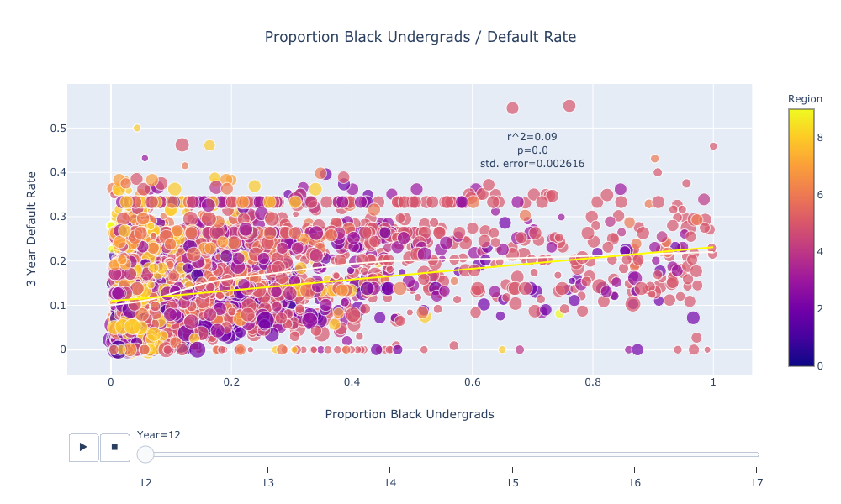

Figure 4: Although the regression yielded a p-value of 0, the R²-value is not high enough to render the result meaningful.